WIPRO CAPSTONE PROJECT REPORT

Name | Shaik Sumera
Superset ID | 5483070
Organization | Wipro
Project Type | Capstone Project
Project Name | Automation Testing using Selenium Pytest Framework
 | Automation Testing using Behave BDD Framework
Domain | E-Commerce
Module Title | Women Fashion hopping Module

SYNOPSIS
The Wipro Capstone Project focuses on automating the Myntra Women Fashion Shopping module using two separate automation frameworks: Selenium WebDriver with Python PyTest framework and Behave BDD framework. The automation validates women category navigation, product selection, saree module navigation, filter selection, sorting functionality, color selection, size selection, add to bag workflow, and shopping bag validation process.
The framework was designed using the Page Object Model (POM) architecture to improve maintainability, scalability, and code reusability. Screenshots, logs, reports, and reusable utility components were integrated to support execution tracking, reporting, and debugging.
The project also includes both positive and negative testing scenarios using industry-standard automation testing practices. The automation framework validates critical e-commerce functionalities and ensures accurate workflow execution across the Myntra shopping application.

PROJECT DESCRIPTION
The automation framework automates the end-to-end workflow of the Myntra Women Fashion Shopping module. The framework performs women category navigation, saree product selection, filter selection, sorting validation, color selection, size selection, add to bag workflow, and shopping bag validation.
Separate page classes were implemented for Home, Women, Saree, Filter, Product, and Cart modules using Selenium Python Page Object Model framework.
The project also includes Behave BDD implementation where business scenarios are written in Gherkin syntax and integrated with Selenium automation scripts.

SELENIUM PYTEST FRAMEWORK

TEST STRATEGY
The project uses Selenium WebDriver with Python PyTest framework for automation testing. The framework supports:
- End-to-End Testing
- Positive Testing
- Negative Testing
- Data-Driven Testing
Tools Used:
- Selenium WebDriver
- PyTest
- Allure Reports
- Logging Module

TEST ENVIRONMENT

Operating System | Windows 11
IDE | PyCharm Unified Product
Browser | Google Chrome (or) Edge
Framework | Selenium WebDriver + PyTest
Design Pattern | Page Object Model (POM)
Reporting Tool | Allure Reports

FRAMEWORK ARCHITECTURE
Myntra Women Automation
├── config
├── logs
├── pages
├── reports
│ ├── allure-results
│ └── allure-report
├── screenshots
├── tests
├── utils
├── conftest.py
├── pytest.ini
└── requirements.txt

TEST EXECUTION
The automation suite includes:
- 1 End-to-End Test Case
- 4 Positive Test Cases
- 2 Negative Test Cases
The End-to-End test validates the complete Myntra Women Fashion Shopping workflow from category navigation until place order verification.
SELENIUM TEST CASE SUMMARY
S.No | Test Type | Test Scenario | Expected Result | Status
1 | End-to-End | Complete Saree Purchase Workflow | User successfully completes saree selection workflow until Place Order page | Passed
2 | Positive | Kurti Page Navigation Validation | Kurti products page displayed successfully | Passed
3 | Positive | Pink T-shirt Filter Validation | Pink color filtered T-shirt products displayed successfully | Passed
4 | Positive | Earrings Add to Bag Validation | Earrings product added to bag successfully | Passed
5 | Positive | Flats Page Sorting Display Validation | Flats products  Sorting By displayed successfully | Passed
6 | Negative | Size Selection Validation | Size validation message displayed successfully | Passed
7 | Negative | Invalid Pincode Validation | Pincode validation message displayed successfully | Passed

END TO END FLOW VALIDATION
The End-to-End automation validates the complete business workflow including:
• Women Section Navigation
• Saree Page Navigation
• Blue Color Filter Selection
• Saree Product Selection
• Add to Bag Validation
• Shopping Bag Navigation
• Product Quantity Update
• Place Order Navigation
• Login Page Verification
POSITIVE TEST CASES
Positive Test Case 1 – Kurti Page Navigation
• Validates successful navigation to the Myntra Kurti page
• Verifies Kurti products page loading
• Checks Women category navigation successfully
Positive Test Case 2 – Pink T-shirt Filter Validation
• Validates Pink color filter functionality
• Applies Pink color filter on T-shirt products
• Verifies filtered Pink T-shirt products displayed successfully
Positive Test Case 3 – Earrings Add to Bag Validation
• Validates Earrings product selection functionality
• Selects first Earrings product
• Adds selected product to shopping bag
• Verifies successful add to bag validation
Positive Test Case 4 – Flats Sorting Validation
• Validates Flats product sorting functionality
• Opens Flats products page
• Applies product sorting option
• Verifies sorted Flats products displayed successfully
NEGATIVE TEST CASES
Negative Test Case 1 – Size Selection Validation
• Opens T-shirt product page
• Clicks Add to Bag without selecting size
• Validates application error handling
• Verifies display of size selection validation message
• Ensures product cannot be added without size selection
Negative Test Case 2 – Invalid Pincode Validation
• Opens product details page
• Clicks Check button without entering pincode
• Validates pincode field error handling
• Verifies display of pincode validation message
• Ensures empty pincode values are not accepted

ALLURE REPORTS
- Integrated Allure Reports with PyTest
- Generates professional execution reports
- Displays passed and failed test status
- Captures screenshots during execution
- Maintains execution history
- Displays step-by-step execution flow
- Helps debugging and tracking failures
- Provides detailed execution summary

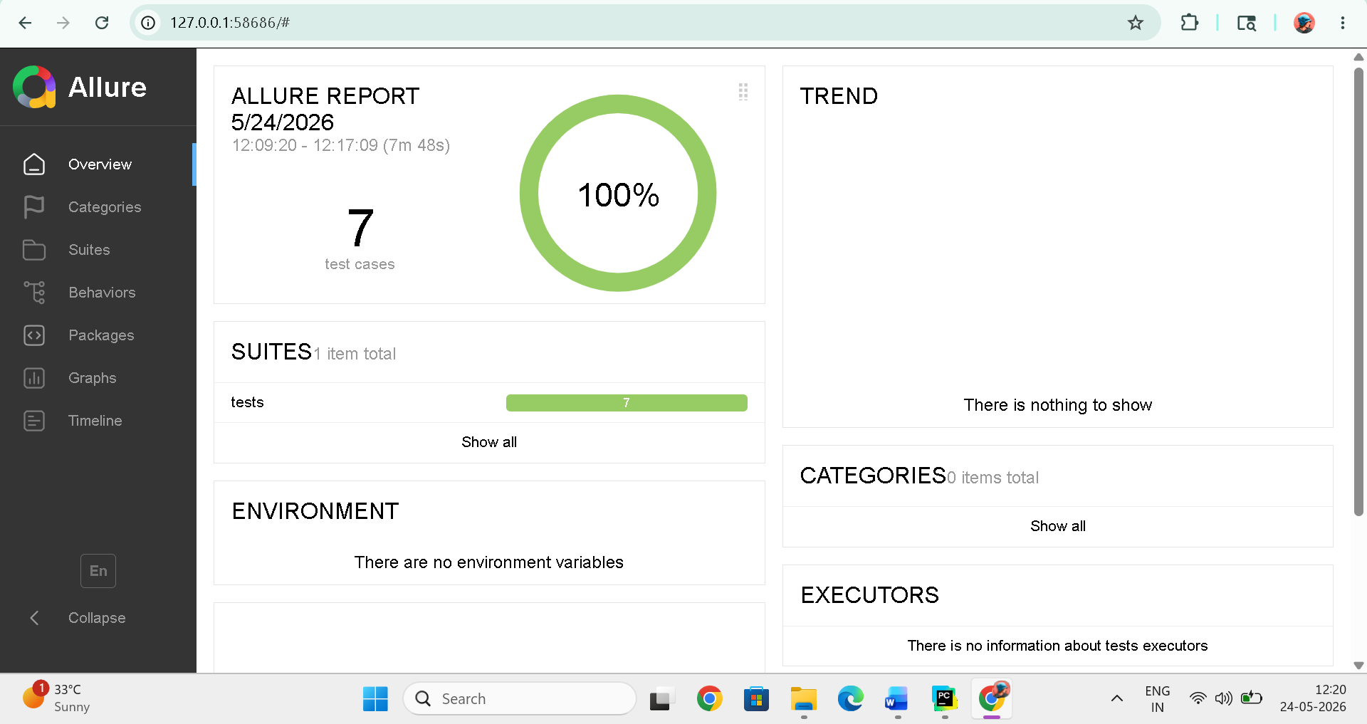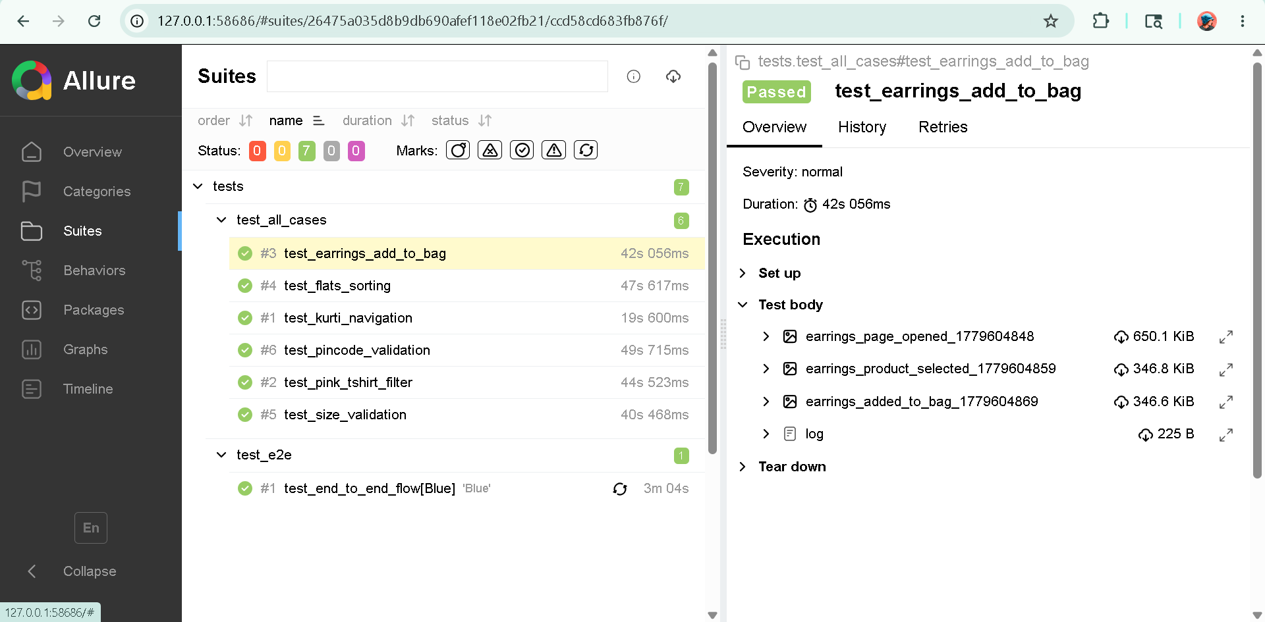

TEST OUTPUTS
The framework automatically captures screenshots during important execution stages including Women section navigation, Saree page navigation, filter selection page, product details page, shopping bag page, and Place Order page.
Detailed execution logs are generated using Python logging framework for debugging and execution tracking.

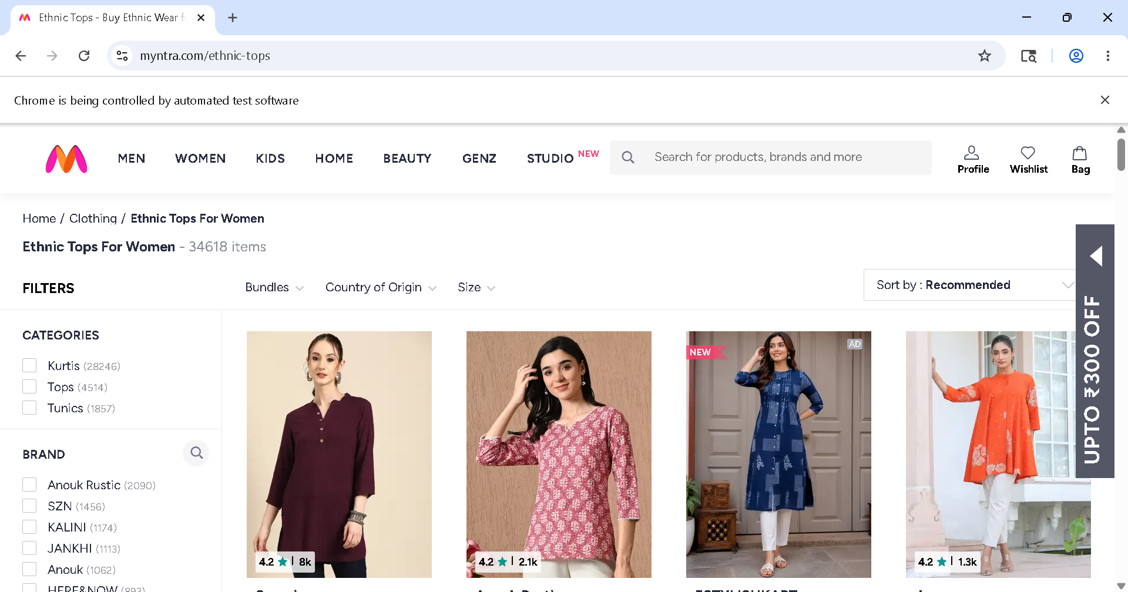
Fig 1: Kurti Page Navigation
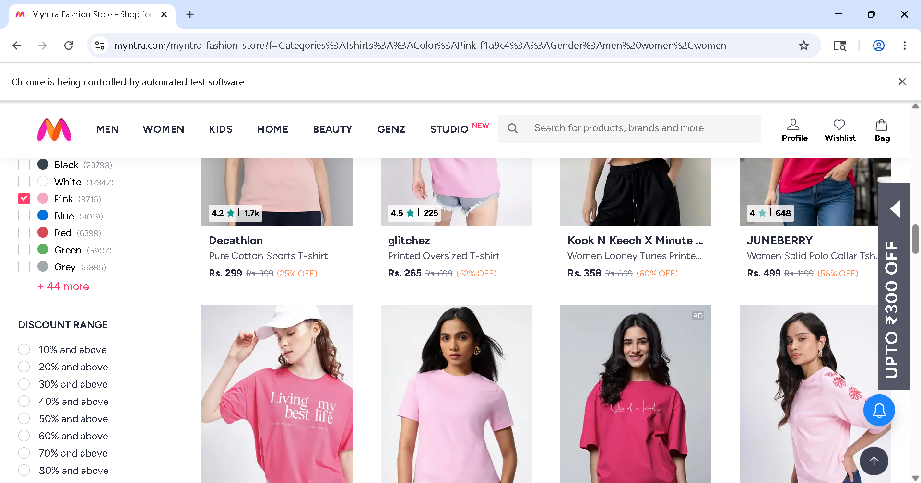
Fig 2: Pink T-Shirt Filter
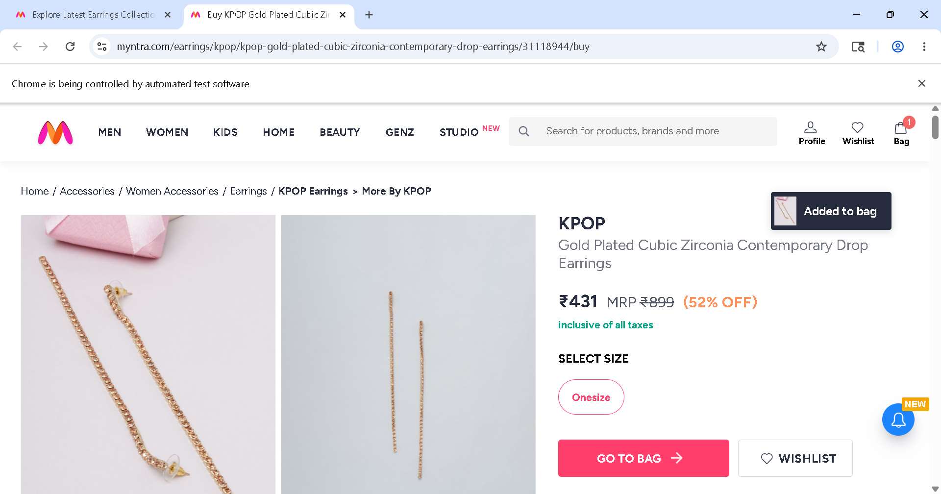
Fig 3: Earrings Add to Bag
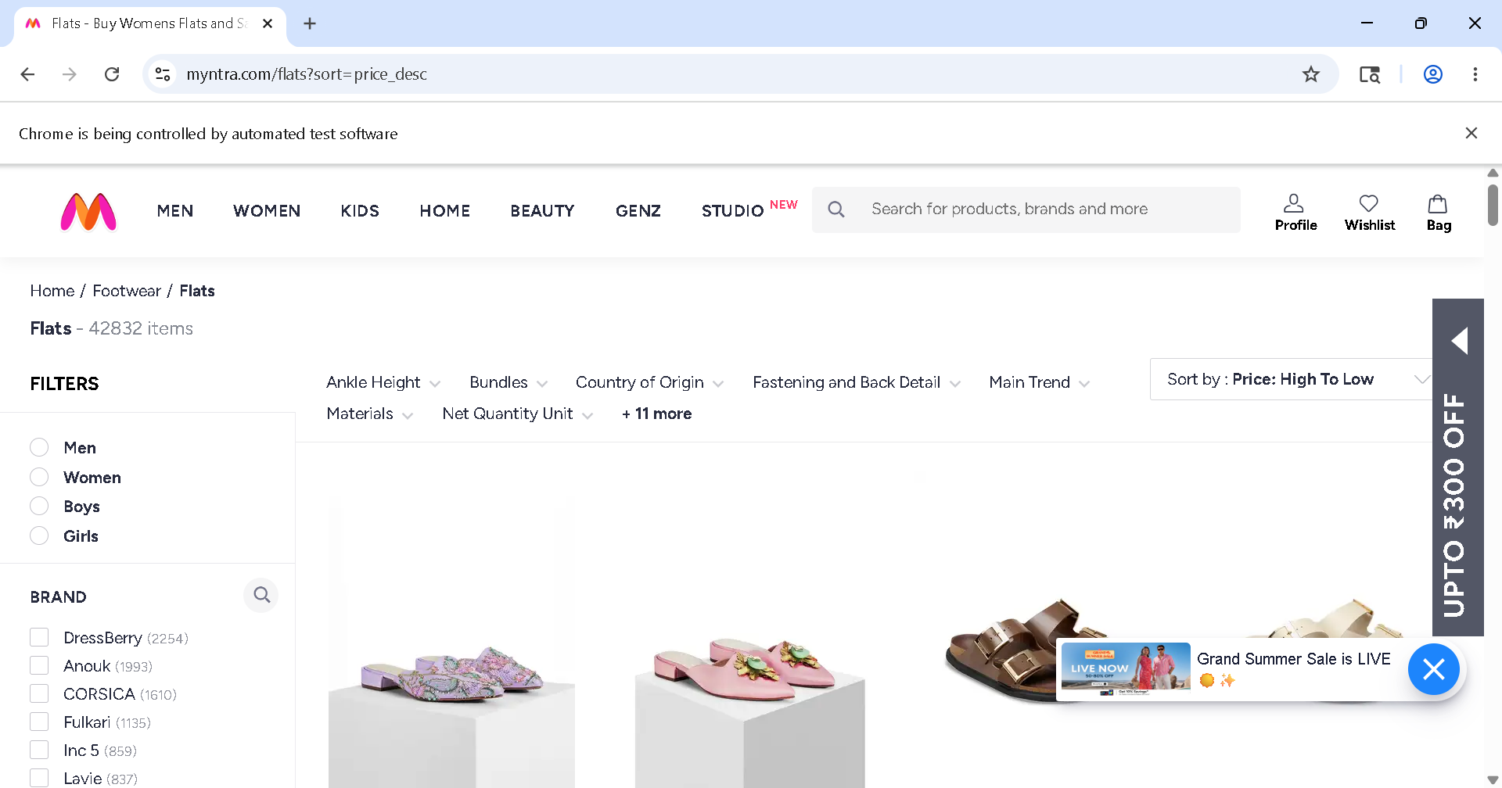

Fig 4: Flats Sorting
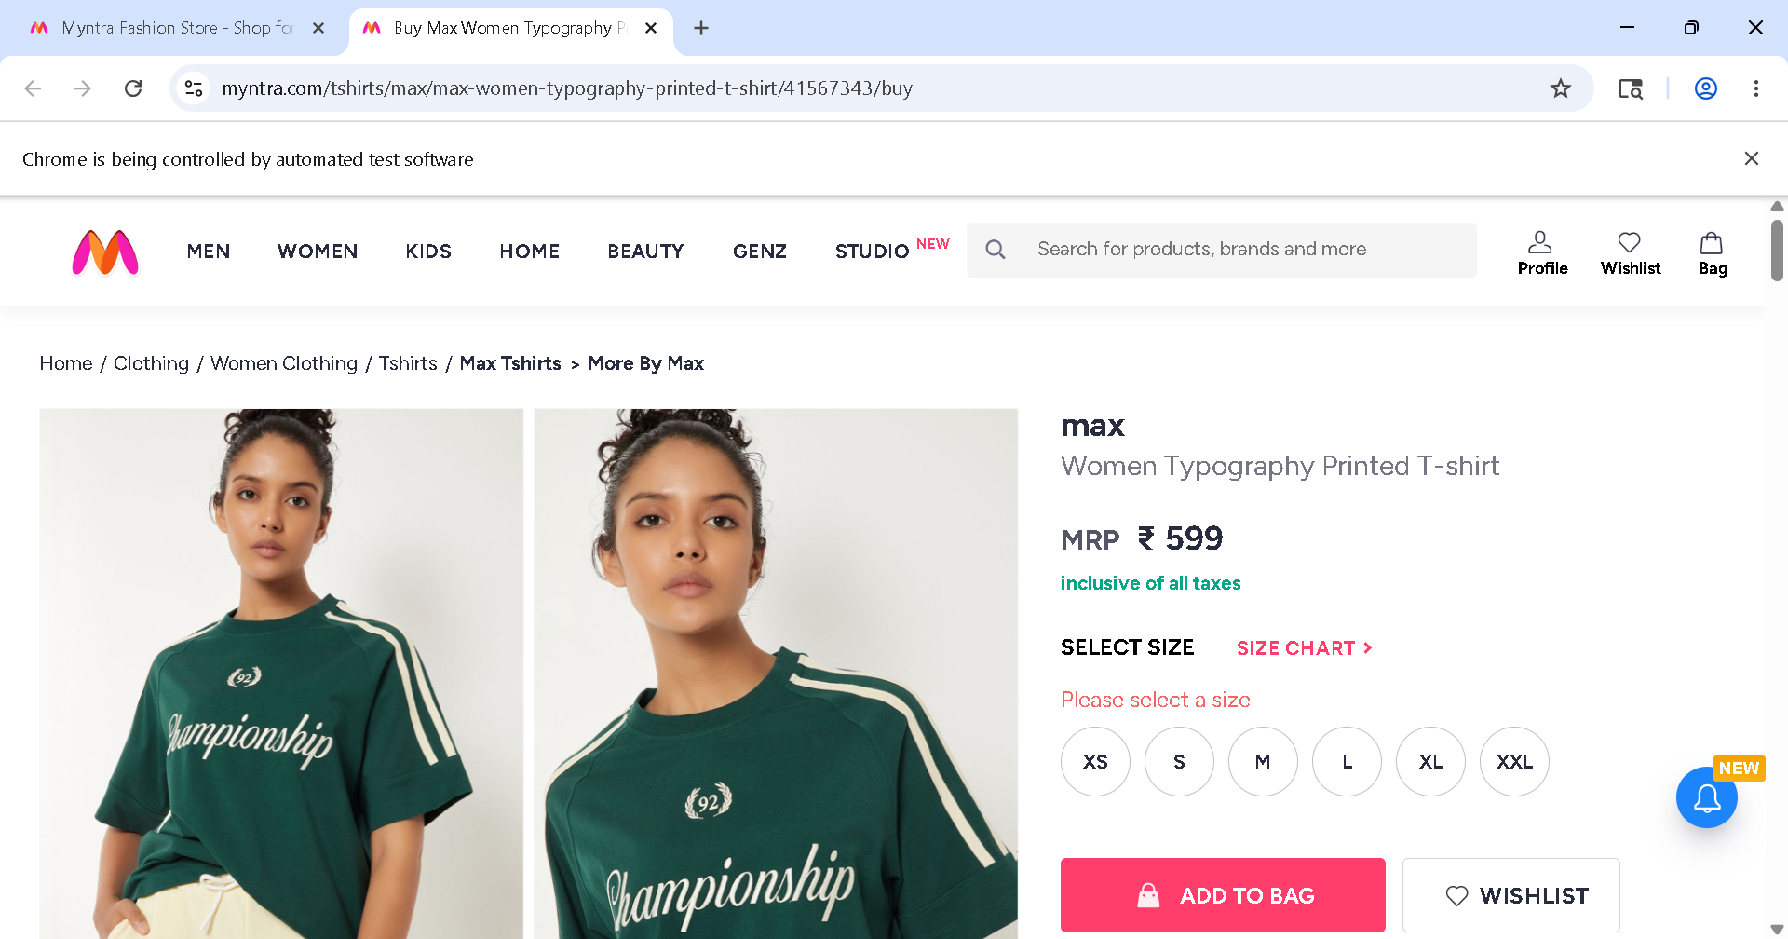
Fig 5: Invalid select a size
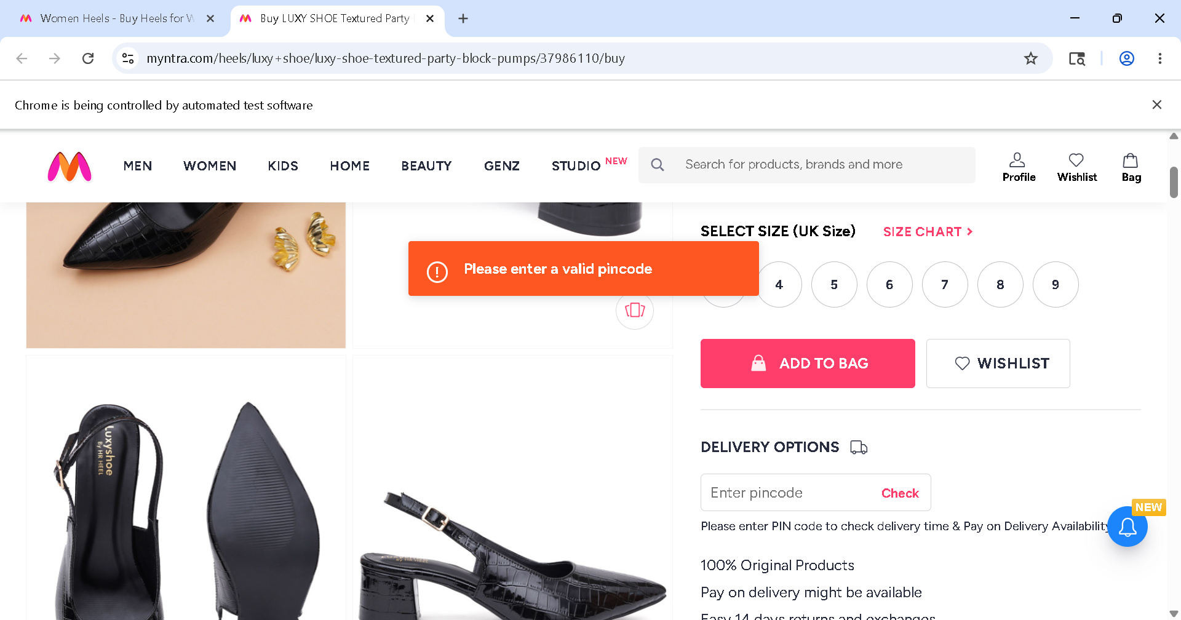
Fig 6: Invalid Pincode

TEST REPORT
- Total Tests Executed: 7
- Tests Passed: 7
- Tests Failed: 0
- Automation Accuracy: 100%

CONCLUSION
The Selenium PyTest automation framework successfully validates the Myntra Women Fashion Shopping application using End-to-End, Positive and Negative testing approaches.
The framework is designed using:
• Selenium WebDriver
• PyTest Framework
• Page Object Model (POM)
• Allure Reporting
• Logging Framework
• Data-Driven Testing
The automation framework improves:
• Test maintainability
• Reusability
• Scalability
• Reporting quality
• Automation reliability
The framework successfully validates critical business workflows including Women section navigation, product filtering, sorting validation, product selection, add to bag workflow, shopping bag navigation, and Place Order verification.
All test cases executed successfully with professional reporting, screenshot capture and detailed execution logs.
Overall, the project demonstrates a practical and professional Selenium automation framework for real-world e-commerce web application testing.

SELENIUM BDD FRAMEWORK

TEST STRATEGY
The project uses Selenium WebDriver with Python Behave BDD framework for automation testing. End-to-End Testing
- Positive Testing
- Negative Testing
- Data-Driven Testing
- Behavior-Driven Development (BDD)
Tools Used:
- Selenium WebDriver
- Behave
- Allure Reports
- Logging Module

TEST ENVIRONMENT
Operating System | Windows 11
IDE | PyCharm Unified Product
Browser | Google Chrome (or) Edge
Framework | Selenium WebDriver + Behave
Design Pattern | Page Object Model (POM)
Reporting Tool | Allure Reports
Test Approach | Behavior Driven Development

FRAMEWORK ARCHITECTURE
Myntra-Women Section
├── config
├── features
│ ├── end_to_end.feature
│ ├── test_cases.feature
│ ├── environment.py
│ └── steps
│ ├── end_to_end.steps
│ └── test_cases.steps
├── reports
│ ├── allure-results
│ └── allure-report
├── screenshots
├── testdata
├── logs
├── utils
├── behave.ini
├── runtest.py
└── requirements.txt

TEST EXECUTION
The automation suite includes:
- 1 End-to-End Test Scenario
- 4 Positive Test Scenarios
- 2 Negative Test Scenarios
The End-to-End scenario validates the complete Myntra Women Fashion Shopping workflow from Women section navigation until Place Order verification.
SELENIUM TEST CASE SUMMARY
S.No | Test Type | Test Scenario | Expected Result | Status
1 | End-to-End | Complete Saree Purchase Workflow | User successfully completes saree selection workflow until Place Order page | Passed
2 | Positive | Kurti Page Navigation Validation | Kurti products page displayed successfully | Passed
3 | Positive | Pink T-shirt Filter Validation | Pink color filtered T-shirt products displayed successfully | Passed
4 | Positive | Earrings Add to Bag Validation | Earrings product added to bag successfully | Passed
5 | Positive | Flats Page Sorting Validation | Flats products Sorting  successfully | Passed
6 | Negative | Size Selection Validation | Size validation message displayed successfully | Passed
7 | Negative | Invalid Pincode Validation | Pincode validation message displayed successfully | Passed

END-TO-END FLOW VALIDATION
The End-to-End automation validates the complete business workflow including:
• Myntra Application Launch
• Women Section Navigation
• Saree Page Navigation
• Blue Color Filter Selection
• Saree Product Selection
• Add to Bag Validation
• Shopping Bag Navigation
• Product Quantity Update
• Place Order Navigation
• Login Page Verification
POSITIVE TEST CASES
Positive Test Case 1 – Kurti Page Navigation
• Validates successful navigation to the Myntra Kurti page
• Verifies Kurti products page loading
• Checks Women category navigation successfully
Positive Test Case 2 – Pink T-shirt Filter Validation
• Validates Pink color filter functionality
• Applies Pink color filter on T-shirt products
• Verifies filtered Pink T-shirt products displayed successfully
Positive Test Case 3 – Earrings Add to Bag Validation
• Validates Earrings product selection functionality
• Selects first Earrings product
• Adds selected product to shopping bag
• Verifies successful add to bag validation
Positive Test Case 4 – Flats Sorting Validation
• Validates Flats product sorting functionality
• Opens Flats products page
• Applies product sorting option
• Verifies sorted Flats products displayed successfully
NEGATIVE TEST CASES
Negative Test Case 1 – Size Selection Validation
• Opens T-shirt product page
• Clicks Add to Bag without selecting size
• Validates application error handling
• Verifies display of size selection validation message
• Ensures product cannot be added without size selection
Negative Test Case 2 – Invalid Pincode Validation
• Opens product details page
• Clicks Check button without entering pincode
• Validates pincode field error handling
• Verifies display of pincode validation message
• Ensures empty pincode values are not accepted

BDD IMPLEMENTATION
The framework follows Behaviour Driven Development using:
- Feature Files
- Step Definition Files
- Gherkin Syntax
- Given-When-Then Structure
ALLURE REPORTS
- Integrated Allure Reports with Behave BDD
- Generates professional execution reports
- Displays passed and failed scenario status
- Captures screenshots during execution
- Maintains execution history
- Displays step-by-step scenario execution flow
- Helps debugging and tracking failures Provides detailed execution summary
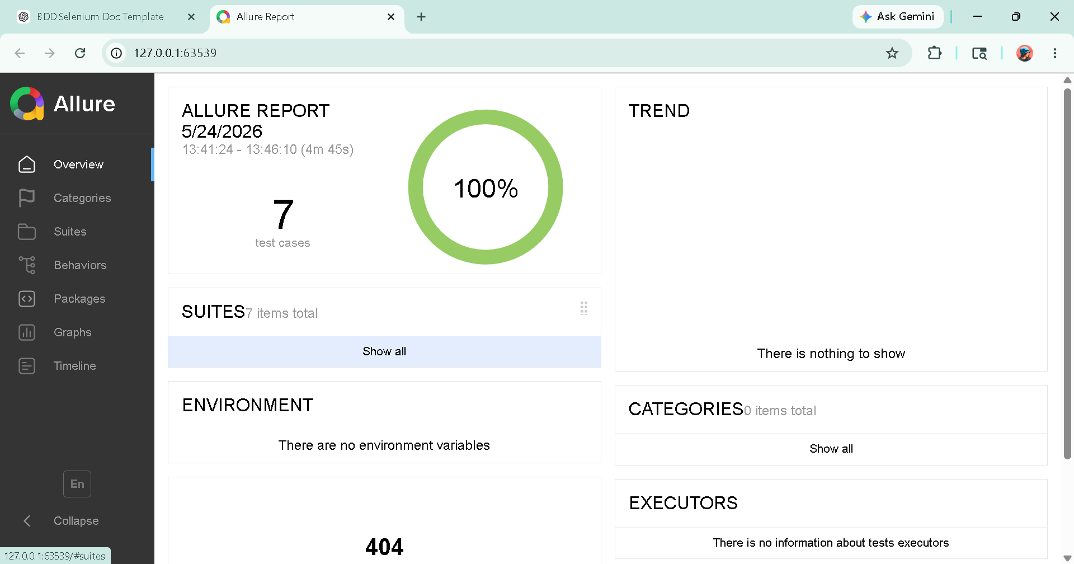

TEST OUTPUTS
The framework automatically captures screenshots during important execution stages including Women section navigation, Saree page navigation, filter selection page, product details page, shopping bag page, and Place Order page.
Detailed execution logs are generated using Python logging framework for debugging and execution tracking.

Fig 1: Kurti Page Navigation

Fig 2: Pink T-Shirt Filter Page

Fig 3: Earrings Add to Bag

Fig 4: Flats Sorting By Page

Fig 5: Invalid select size

Fig 6: Invalid Pincode Check

TEST REPORT
- Total Scenarios Executed: 7
- Scenarios Passed: 7
- Scenarios Failed: 0
- Automation Accuracy: 100%

CONCLUSION
The Selenium Behave BDD automation framework successfully validates the Myntra Women Fashion Shopping application using Behaviour Driven Development methodology.
The framework is implemented using:
• Selenium WebDriver
• Behave BDD Framework
• Gherkin Feature Files
• Step Definition Files
• Page Object Model (POM)
• Allure Reporting
• Data-Driven Testing
The framework validates complete business workflows including:
• Myntra Application Launch
• Women Section Navigation
• Saree Page Navigation
• Filter Application
• Product Selection
• Add to Bag Validation
• Shopping Bag Navigation
• Place Order Navigation
• Login Page Verification
The implementation of Feature Files and Given-When-Then structure improves readability, maintainability and collaboration between technical and non-technical users.
The framework also includes:
• Professional Allure Reports
• Screenshot Evidence
• Detailed Execution Logs
• Positive and Negative Testing
• Reusable Automation Components
All scenarios executed successfully with accurate validations and detailed reporting.
Overall, the project demonstrates a professional real-world BDD automation framework with scalable architecture, reusable components and reliable automated testing practices.

